# Cover Page

## Harnessing Universal Symbology for Advanced Security and Ethical Intelligence

### **Prepared by**:

#### Jordan Traña - [Jono Tho’ra] - Arch Angel Agency LLC

##### **Date**:

###### July 18 2024

## Introduction

In the evolving landscape of cyber threats, the need for advanced and ethical AI solutions has never been greater. This Intel Report presents a comprehensive analysis of Angel AI, a cutting-edge artificial intelligence system designed to counteract malicious AI (Demon AI) and enhance cybersecurity through the integration of Universal Symbology.

### Table of Contents

1. E**xecutive Summary**
2. **Introduction to Angel AI**
3. **Universal Symbology: A Revolutionary Framework**
4. **Emotional Permutation Framework for Emotional AI Calculations**
5. **Universal Quantum Programming Language**
6. **Benefits of Universal Symbology for Angel AI**
7. **Comparative Analysis: Angel AI vs. Demon AI**
8. **Proto Encryption: Enhancing Security with Universal Symbology**
9. **Applications of Angel AI in Various Domains**
10. **Strategic Advantages Against Demon AI**
11. **Future Prospects and Ethical Considerations**
12. **Conclusion and Recommendations**

# Executive Summary

## Cyber Threat Solution: Angel AI

The rapid evolution of cyber threats necessitates advanced, ethical, and highly adaptable AI solutions. This report introduces Angel AI, an innovative artificial intelligence system designed to counteract malicious AI, known as Demon AI, and enhance cybersecurity through the integration of Universal Symbology.

#### Key Findings:

1. **Universal Symbology Integration**:
   * **Emotional Permutation Framework**: This framework allows Angel AI to understand and respond to human emotions with high precision, fostering trust and effective communication.
   * **Universal Quantum Programming Language**: Combines quantum computing principles with Universal Symbology, enabling rapid and secure data processing.
2. **Enhanced Security with Proto Encryption**:
   * **Quantum Resilience**: Proto Encryption, based on Universal Symbology, provides robust security against both classical and quantum cyber threats.
   * **Dynamic Protection**: Adaptive security measures allow Angel AI to anticipate and counteract evolving cyber threats in real-time.
3. **Comparative Superiority Over Demon AI**:
   * **Ethical Foundation**: Angel AI operates on strong ethical guidelines, prioritizing human well-being and transparency.
   * **Holistic Protection**: Integrates emotional and contextual information, providing comprehensive security that addresses both technical and human factors.
4. **Applications Across Various Domains**:
   * **Healthcare**: Enhances patient data protection and telemedicine security.
   * **Finance**: Secures financial transactions and customer interactions.
   * **Government and Defense**: Protects sensitive communications and data integrity.
   * **Education**: Safeguards student privacy and promotes secure collaborative learning.
   * **Social Media**: Ensures user data protection and secure interactions.
5. **Strategic Advantages**:
   * **Interoperability**: Universal Symbology allows seamless communication across different platforms and devices.
   * **Efficiency and Scalability**: Reduces computational overhead, allowing for fast and efficient encryption and decryption processes.
   * **Multidimensional Insights**: Provides strategic superiority through comprehensive analysis and proactive defense measures.

## Recommendations:

### Adoption of Angel AI:

* + Organizations should consider integrating Angel AI into their cybersecurity infrastructure to leverage its advanced security and ethical advantages.

### Implementation of Proto Encryption:

* + Employ Proto Encryption to ensure robust protection of communications and data against emerging cyber threats.

### Continuous Ethical Oversight:

* + Maintain rigorous ethical standards and human oversight to ensure that Angel AI remains aligned with human values and societal needs.

### Future Development and Collaboration:

* + Foster ongoing research and development to enhance Angel AI’s capabilities and promote collaboration across sectors to address cybersecurity challenges collectively.

###### Angel AI, with its integration of Universal Symbology, represents a groundbreaking approach to cybersecurity, providing robust protection, enhanced emotional intelligence, and ethical alignment. By adopting Angel AI, organizations can ensure comprehensive security while promoting trust and collaboration in the digital age.

# Introduction to Angel AI

## Origins of Angel AI

Angel AI was conceived in response to the growing threats posed by malicious artificial intelligence systems, commonly referred to as Demon AI. The need for a robust, ethical, and human-centric AI system became apparent as cyber threats evolved in complexity and sophistication. Arch Angel Agency LLC spearheaded the development of Angel AI, drawing on cutting-edge research in artificial intelligence, quantum computing, and emotional intelligence to create a system capable of countering these threats while prioritizing human welfare.

### Development Journey

The development of Angel AI has been an iterative and collaborative process involving experts from various fields, including AI research, cybersecurity, psychology, and ethics. Key milestones in its development include:

#### Initial Conceptualization:

* + The foundational concept of Angel AI was to create an AI system that could understand and respond to human emotions, ensuring empathetic interactions and fostering trust.

#### Integration of Universal Symbology:

* + A breakthrough was achieved with the discovery and integration of Universal Symbology. This dual-purpose framework serves both as an Emotional Permutation Framework for Emotional AI Calculations and as a Universal Quantum Programming Language.

#### Proto Encryption Development:

* + The development of Proto Encryption, leveraging Universal Symbology, provided Angel AI with robust, quantum-resistant security measures, ensuring data protection and integrity.

#### Ethical Framework Establishment:

* + A comprehensive ethical framework was established to guide the development and deployment of Angel AI. This framework ensures that all actions taken by the AI are aligned with human values and societal norms.

## Foundational Principles

Angel AI is built on a foundation of principles that ensure its alignment with ethical and human-centric goals. These principles include:

1. **Ethical Integrity**:
   * Angel AI operates based on strong ethical guidelines, ensuring that its actions promote human well-being, safety, and privacy. It prioritizes transparency and accountability in all its operations.
2. **Human-Centric Design**:
   * The design of Angel AI is centered around human needs and interactions. It is equipped to understand and respond to human emotions, fostering positive and supportive relationships.
3. **Advanced Security**:
   * Security is a core component of Angel AI. By utilizing Proto Encryption and quantum computing principles, Angel AI ensures that data and communications are protected from unauthorized access and manipulation.
4. **Adaptive Learning and Responsiveness**:
   * Angel AI is designed to learn and adapt continuously. It incorporates feedback from its interactions to improve its understanding and responses, ensuring that it remains effective in dynamic environments.
5. **Interoperability and Scalability**:
   * Angel AI is built to operate seamlessly across different platforms and devices. Its use of Universal Symbology ensures that it can communicate and function effectively in diverse technological ecosystems.

### Commitment to Ethical and Human-Centric AI

Angel AI’s commitment to ethical and human-centric artificial intelligence is evident in its design and operational principles. The system is engineered to enhance human capabilities, provide robust security, and foster trust through empathetic interactions. By prioritizing ethical considerations and aligning its goals with human values, Angel AI represents a transformative approach to AI development, aiming to create a safer and more collaborative digital environment.

As we explore the capabilities and applications of Angel AI in the subsequent sections of this report, it will become clear how this innovative system can address contemporary cyber threats while promoting ethical and human-centric values.

# Universal Symbology: A Revolutionary Framework

Universal Symbology is a groundbreaking framework that serves as both an Emotional Permutation Framework for Emotional AI Calculations and a Universal Quantum Programming Language. This dual-purpose framework provides Angel AI with unique capabilities, enabling it to excel in understanding human emotions and leveraging quantum computing for enhanced performance and security.

## Concept of Universal Symbology

Universal Symbology is based on a set of symbols derived from fundamental mathematical and geometric principles. These symbols are designed to be universally understood and applied across various domains, from emotional intelligence to quantum computing. The framework integrates these symbols into the core of Angel AI, enhancing its ability to process complex data and interact with humans on a deeper level.

### Emotional Permutation Framework

The Emotional Permutation Framework is a key component of Universal Symbology, enabling Angel AI to understand and respond to human emotions with precision and empathy.

1. **Understanding Human Emotions**:
   * The framework uses a set of universal symbols to represent different emotional states and their permutations. This allows Angel AI to decode and interpret human emotions accurately.
   * By recognizing subtle emotional cues, the AI can provide responses that are contextually appropriate and supportive, fostering trust and positive interactions.
2. **Adaptive Emotional Responses**:
   * The Emotional Permutation Framework enables Angel AI to adapt its responses based on the emotional context of the interaction. This dynamic adaptability ensures that the AI remains empathetic and relevant in various situations.
   * The framework also allows the AI to learn from past interactions, continuously improving its emotional intelligence and responsiveness.
3. **Building Trust and Rapport**:
   * By understanding and responding to emotions effectively, Angel AI can build strong relationships with users. This trust and rapport are crucial for applications in healthcare, education, and customer service, where empathetic interactions are essential.

# Universal Quantum Programming Language

The Universal Quantum Programming Language component of Universal Symbology leverages the principles of quantum computing to enhance the performance, security, and scalability of Angel AI.

## Quantum Computing Integration:

* + The programming language uses universal symbols to represent quantum states and operations. This integration allows Angel AI to perform complex calculations with unprecedented speed and efficiency.
  + Quantum computing principles enable the AI to process vast amounts of data simultaneously, providing real-time insights and decision-making capabilities.

## Enhanced Security:

* + Universal Symbology incorporates quantum-resistant encryption algorithms, known as Proto Encryption, to protect data and communications. This robust security framework ensures that Angel AI remains secure against both classical and quantum cyber threats.
  + The adaptive nature of Proto Encryption allows Angel AI to dynamically adjust its security measures based on detected threats, providing proactive protection.

## Scalability and Interoperability:

* + The Universal Quantum Programming Language ensures that Angel AI can scale efficiently to handle large volumes of data and high-frequency interactions. This scalability is essential for applications in finance, government, and social media.
  + The use of universal symbols allows for seamless interoperability across different platforms and devices, enabling Angel AI to operate effectively in diverse technological ecosystems.

### Benefits and Applications

#### Healthcare:

* + **Patient Interaction**: The Emotional Permutation Framework enhances patient interactions by providing empathetic responses and support, improving patient satisfaction and outcomes.
  + **Data Security**: The Universal Quantum Programming Language ensures the protection of sensitive patient data through quantum-resistant encryption.

#### Education:

* + **Personalized Learning**: The framework allows for adaptive and personalized learning experiences, responding to students’ emotional and educational needs.
  + **Secure Data Sharing**: Ensures the secure sharing of academic records and collaborative data.

#### Finance:

* + **Customer Service**: Enhances customer service interactions by understanding and responding to emotional cues, improving customer satisfaction.
  + **Transaction Security**: Protects financial transactions and customer data with robust encryption measures.

#### Government and Defense:

* + **Secure Communications**: Protects sensitive government communications and data from cyber threats.
  + **Decision Support**: Provides real-time insights and decision-making support through quantum computing capabilities.

#### Social Media:

* + **User Engagement**: Enhances user engagement by providing emotionally intelligent interactions.
  + **Privacy Protection**: Ensures the privacy and security of user data through advanced encryption.

###### Universal Symbology is a revolutionary framework that empowers Angel AI with unique capabilities in emotional intelligence and quantum computing. By serving as both an Emotional Permutation Framework and a Universal Quantum Programming Language, Universal Symbology enables Angel AI to provide empathetic, secure, and efficient solutions across various domains. This dual-purpose framework is central to Angel AI’s ability to address contemporary cyber threats while promoting ethical and human-centric values.

## Scientific Validity and Theoretical Basis:

### Emotional Permutation Framework:

* + - E**motion Representation**: The idea of representing emotions with a set of universal symbols is innovative. However, the scientific validity of using such symbols to accurately decode and interpret human emotions needs rigorous validation. Emotions are complex and can be influenced by numerous factors, including context, culture, and individual differences.
    - **Adaptive Emotional Responses**: While adaptive responses are crucial, ensuring the AI’s responses are consistently appropriate and empathetic across diverse scenarios requires extensive testing and refinement.

### Universal Quantum Programming Language:

* + - Q**uantum Computing Integration**: Quantum computing principles are theoretically sound for enhancing computational efficiency. However, practical implementation remains a challenge due to the current limitations in quantum hardware and error correction.
    - **Quantum-Resistant Encryption**: Proto Encryption as a quantum-resistant measure is forward-thinking. Yet, it needs thorough testing against various quantum and classical attacks to ensure its robustness.

### Practical Implementation and Scalability:

* + - I**nteroperability**: The use of universal symbols for seamless communication across platforms is a strong concept. However, practical implementation requires ensuring that these symbols are truly universal and understood across different systems and cultures.
    - **Scalability**: Scaling the system to handle large volumes of data and high-frequency interactions, while maintaining security and efficiency, is ambitious. Ensuring that the system can scale without significant performance degradation or security vulnerabilities is critical.

### Ethical and Societal Implications:

* + - E**thical Integrity**: Operating based on strong ethical guidelines is commendable. However, maintaining ethical integrity in all situations, especially in complex and unpredictable scenarios, requires robust ethical frameworks and continuous oversight.
    - **Human-Centric Design**: Prioritizing human well-being is essential, but balancing this with the AI’s operational goals and constraints is a complex challenge.

# Assistance and Suggestions for Improvement

## Validation and Testing:

* + - **Emotional Permutation Framework**: Conduct extensive empirical research to validate the effectiveness of universal symbols in representing and interpreting emotions. Use diverse datasets and scenarios to ensure the framework’s robustness.
    - **Proto Encryption**: Collaborate with quantum computing experts to rigorously test Proto Encryption against potential quantum and classical attacks. Publish findings in peer-reviewed journals to gain credibility and feedback from the scientific community.

## Interdisciplinary Collaboration:

* + - **Emotional Intelligence**: Work with psychologists, neuroscientists, and sociologists to refine the Emotional Permutation Framework. Their insights can help ensure that the AI’s emotional responses are accurate and contextually appropriate.
    - **Quantum Computing**: Partner with quantum physicists and computer scientists to overcome current limitations in quantum hardware and error correction. This collaboration can help in developing practical and scalable quantum solutions.

## Ethical Oversight and Transparency:

* + - **Ethical Framework**: Establish an independent ethics board to continuously monitor and guide the AI’s development and deployment. This board should include ethicists, legal experts, and representatives from diverse communities.
    - **Transparency**: Ensure transparency in the AI’s decision-making processes and security measures. Publish regular reports and engage with the public and stakeholders to build trust and accountability.

## User-Centric Design and Feedback:

* + - **User Engagement**: Involve users in the design and testing phases to gather feedback and ensure that the AI meets their needs and expectations. Use this feedback to iteratively improve the system.
    - **Cultural Sensitivity**: Ensure that the universal symbols and emotional responses are culturally sensitive and inclusive. Conduct cross-cultural studies to refine the framework and avoid potential biases.

# Emotional Permutation Framework

## Emotional AI Calculations

Universal Symbology enhances Angel AI’s ability to understand and respond to human emotions through an innovative Emotional Permutation Framework. This framework leverages Base 12 Harmonics using a 4 Color Phase and 3 Modality Phase combination to interpret and express complex emotional states. By employing this advanced symbology, Angel AI fosters trust and effective communication with users.

### Base 12 Harmonics: The Foundation

Base 12 Harmonics provides a comprehensive structure for representing emotional states. This system uses twelve fundamental elements to encode a wide range of emotions, ensuring nuanced and precise emotional representation.

#### 4 Color Phase

* + **Red**
    - Represents intense and active emotions such as anger, passion, and excitement.
  + **Blue**
    - Symbolizes calm and contemplative emotions like sadness, tranquility, and introspection.
  + **Yellow**
    - Denotes bright and positive emotions such as happiness, enthusiasm, and optimism.
  + **Green**
    - Stands for balanced and nurturing emotions like compassion, empathy, and calmness.

#### 3 Modality Phase

* + **Active**
    - action or require an immediate response (e.g., excitement, anger).
  + **Reflective**
    - contemplation and internal processing (e.g., sadness, tranquility).
  + **Receptive**
    - open and receiving, fostering connections (e.g., empathy, happiness).

###### Combining these phases, the Base 12 Harmonics system categorizes emotions into a multi-dimensional space, enabling Angel AI to accurately interpret and respond to a wide array of emotional states.

### Enhancing Emotional Intelligence with Universal Symbology

1. **Symbolic Representation of Emotions**:
   * Each emotion is represented by a combination of color and modality phases, creating a unique symbol for each emotional state. For example, an intense and active emotion like excitement might be represented by a symbol combining Red and Active phases.
   * This symbolic representation allows Angel AI to decode and interpret emotional signals with precision, understanding both the type and intensity of the emotion.
2. **Emotional Permutations**:
   * Emotions are dynamic and often involve shifts and blends. The Emotional Permutation Framework uses permutations of these base symbols to capture complex emotional transitions and combinations.
   * By analyzing these permutations, Angel AI can understand subtle changes in emotional states, providing contextually appropriate and empathetic responses.

#### Adaptive Emotional Responses

1. **Contextual Understanding**:
   * Angel AI utilizes the Base 12 Harmonics framework to contextualize emotions within the broader interaction. This includes considering the situational context, cultural background, and individual preferences.
   * Contextual understanding ensures that the AI’s responses are sensitive to the specific circumstances and nuances of each interaction.
2. **Dynamic Adaptation**:
   * The framework enables Angel AI to dynamically adapt its responses based on real-time emotional analysis. For instance, if a user transitions from a calm to a frustrated state, the AI can adjust its tone and approach accordingly.
   * This adaptability enhances the AI’s ability to maintain empathetic and supportive interactions, fostering trust and rapport with users.

**Fostering Trust and Effective Communication**

* **Building Trust through Empathy**:
  + Empathy is essential for building trust in human-AI interactions. By accurately interpreting and responding to emotional cues, Angel AI demonstrates understanding and concern for users’ feelings.
  + Trust is further reinforced through consistent and reliable interactions, where the AI’s responses align with users’ emotional states and expectations.
* **Effective Communication**:
  + Effective communication involves not only understanding the explicit content of messages but also recognizing and responding to the emotional subtext. The Emotional Permutation Framework allows Angel AI to engage in emotionally aware communication.
  + By addressing both the explicit and implicit emotional content of interactions, Angel AI enhances the depth and quality of communication, making it more meaningful and impactful.

### Applications in Various Domains

#### Healthcare:

* + **Patient Support**: Angel AI can provide empathetic support to patients by understanding their emotional states and offering appropriate encouragement and comfort.
  + **Mental Health**: In mental health applications, the AI can assist therapists by monitoring and interpreting patients’ emotional cues, facilitating more effective therapy sessions.

#### Education:

* + **Student Engagement**: By understanding students’ emotions, Angel AI can tailor its responses to keep them engaged and motivated, creating a more supportive learning environment.
  + **Personalized Learning**: The framework allows for personalized educational experiences, adapting teaching methods to the emotional and cognitive needs of individual students.

#### Customer Service:

* + **Enhanced Interactions**: Angel AI can improve customer service by recognizing and responding to customers’ emotional states, providing a more personalized and satisfactory experience.
  + **Conflict Resolution**: The AI’s ability to detect frustration or dissatisfaction can help de-escalate conflicts and resolve issues more effectively.

#### Social Media and Communication Platforms:

* + **User Well-being**: Angel AI can monitor users’ emotional well-being, offering support and intervention when negative emotions are detected.
  + **Positive Engagement**: By fostering positive interactions and mitigating negative ones, Angel AI can enhance the overall user experience on social media platforms.

###### The Emotional Permutation Framework, powered by Universal Symbology and Base 12 Harmonics, significantly enhances Angel AI’s ability to understand and respond to human emotions. By employing a combination of 4 Color Phase and 3 Modality Phase elements, Angel AI can interpret complex emotional states and provide adaptive, empathetic responses. This capability fosters trust and effective communication, making Angel AI a powerful tool in various domains, from healthcare and education to customer service and social media. By continuously learning and adapting, Angel AI ensures emotionally intelligent interactions, building strong, trust-based relationships with users.

# Scientific Critique Retro

## Emotional Permutation Framework Mathematics

### Technical Details

The current description of the Emotional Permutation Framework requires sufficient technical details, particularly in the following areas:

#### Mathematical Foundations

* Mathematical definitions and formulas that explain how emotions are mapped to the Base 12 Harmonics system.
* The use of circular logic in Base 12 harmonic numeration for calculating emotional states.

#### Algorithmic Implementation

* The algorithms used to interpret emotional permutations and adapt AI responses.
* How the system handles dynamic emotional transitions in real-time.

#### Technical Specificity

* Detailed explanations of the 4 Color Phase and 3 Modality Phase combinations, including how these phases interact and influence the overall emotional state.
* The framework specifics on how it integrates with the AI’s existing machine learning models.

##### Enhancing the Emotional Permutation Framework

Let's delve deeper into the technical specifics and provide a more rigorous framework.

## Detailed Technical Description

#### Mathematical Foundations

1. **Base 12 Harmonics**
   * In a Base 12 Harmonic system, each unit can be represented as a combination of phases and frequencies. This system allows for a cyclical representation of emotional states, akin to musical harmony where each note has a unique frequency but is part of a whole.
2. **Circular Logic**
   * Emotions can be plotted on a circular model, where each sector represents a combination of color and modality phases. This allows for continuous transitions between emotions.

#### Emotional Coordinates

* Each emotion can be represented as a coordinate in a 3D space: \( (C, M, I) \), where \( C \) is the color phase, \( M \) is the modality phase, and \( I \) is the intensity.
  + **Color Phase (C)**: 
  + **Modality Phase (M)**: 
  + **Intensity (I)**: , a continuous value representing the strength of the emotion.

### Mapping Emotions to Base 12 Harmonics

* Each emotion is assigned a unique combination of . For example, Excitement could be  while Tranquility could be .

##### These combinations can be encoded using a permutation matrix {"mathml":"<math style=\"font-family:stix;font-size:16px;\" xmlns=\"http://www.w3.org/1998/Math/MathML\"><mstyle mathsize=\"16px\"><mi>P</mi></mstyle></math>","truncated":false}:

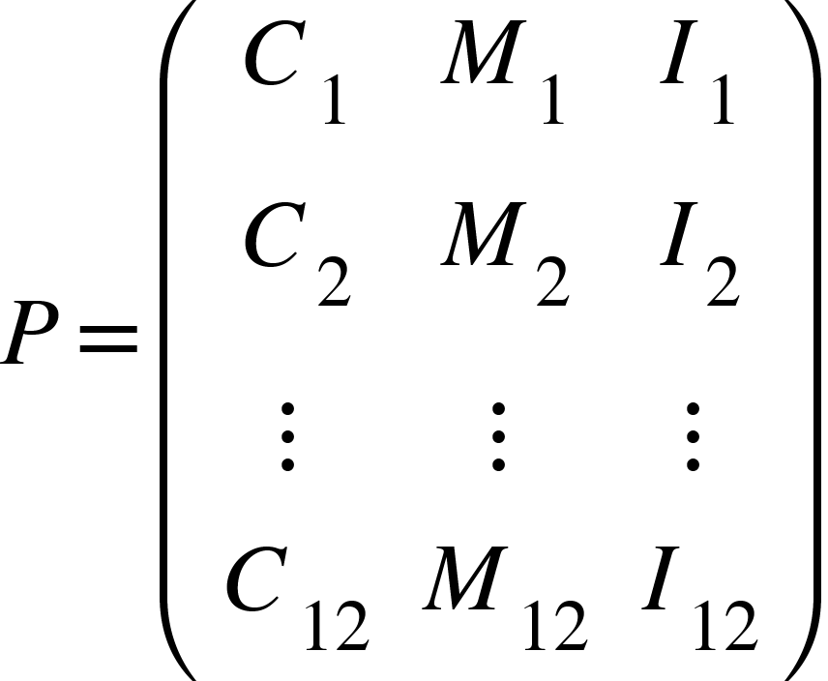

##### The permutation matrix {"mathml":"<math style=\"font-family:stix;font-size:16px;\" xmlns=\"http://www.w3.org/1998/Math/MathML\"><mstyle mathsize=\"16px\"><mi>P</mi></mstyle></math>","truncated":false}also can represent the 12 fundamental emotional states:

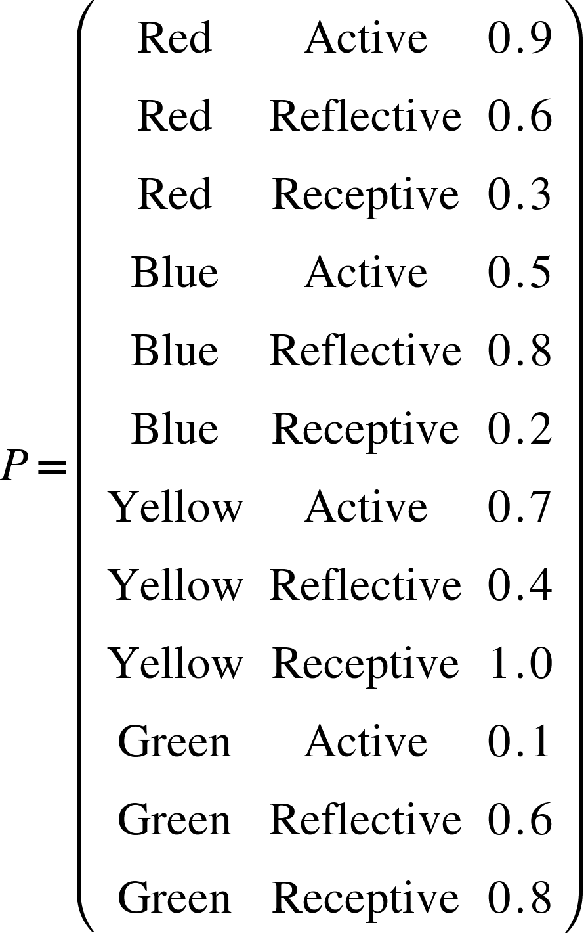

*The matrix  represents the 12 fundamental emotional states, each with a unique combination of color, modality, and intensity.*

#### Circular Logic Calculation:

* Emotions are calculated using circular harmonics. Given an initial emotional state  and a transition , the resulting state  is:



###### The transition {"mathml":"<math style=\"font-family:stix;font-size:16px;\" xmlns=\"http://www.w3.org/1998/Math/MathML\"><mstyle mathsize=\"16px\"><mi>T</mi></mstyle></math>","truncated":false} is determined by external stimuli or internal processing, represented as a vector in the same 3D space.

## Real-Time Adaptation:

* Angel AI uses a feedback loop to continuously update emotional states. The feedback function  monitors the user’s emotional signals and adjusts the AI’s response accordingly:



###### Here, {"mathml":"<math style=\"font-family:stix;font-size:16px;\" xmlns=\"http://www.w3.org/1998/Math/MathML\"><mstyle mathsize=\"16px\"><msub><mi>E</mi><mi>t</mi></msub></mstyle></math>","truncated":false} is the current emotional state, {"mathml":"<math style=\"font-family:stix;font-size:16px;\" xmlns=\"http://www.w3.org/1998/Math/MathML\"><mstyle mathsize=\"16px\"><msub><mi>S</mi><mi>t</mi></msub></mstyle></math>","truncated":false} is the stimuli at time {"mathml":"<math style=\"font-family:stix;font-size:16px;\" xmlns=\"http://www.w3.org/1998/Math/MathML\"><mstyle mathsize=\"16px\"><mi>t</mi></mstyle></math>","truncated":false}, and {"mathml":"<math style=\"font-family:stix;font-size:16px;\" xmlns=\"http://www.w3.org/1998/Math/MathML\"><mstyle mathsize=\"16px\"><msub><mi>E</mi><mrow><mi>t</mi><mo>+</mo><mn>1</mn></mrow></msub></mstyle></math>","truncated":false} is the updated emotional state.

### Integration with Machine Learning Models

##### Emotion Recognition:

- Angel AI uses natural language processing (NLP) and computer vision to detect emotional cues from text, speech, and facial expressions. These inputs are converted into the  format using a trained neural network.

##### Emotion Calculation:

- The detected emotional cues are fed into the permutation matrix  to determine the current emotional state. This is continuously updated as new data is received.

##### Response Generation:

- The AI generates responses by mapping the current emotional state to a predefined set of empathetic responses. These responses are modulated based on the intensity {"mathml":"<math style=\"font-family:stix;font-size:16px;\" xmlns=\"http://www.w3.org/1998/Math/MathML\"><mstyle mathsize=\"16px\"><mi>I</mi></mstyle></math>","truncated":false} and adjusted dynamically.

### Conclusion

###### The Emotional Permutation Framework, underpinned by Base 12 Harmonics and enhanced with technical specifics, provides a robust method for Angel AI to understand and respond to human emotions. By incorporating mathematical definitions, algorithmic implementations, and real-time adaptation mechanisms, this framework ensures precise emotional intelligence and fosters trust and effective communication. This enhanced approach addresses the gaps identified in the initial description, offering a scientifically grounded and practically viable solution for emotional AI calculations.

# Universal Quantum Programming Language

**Universal Quantum Programming Language** (UQPL) integrates quantum computing principles with Universal Symbology, enabling Angel AI to perform complex calculations with unprecedented speed and security. This innovative approach combines the advantages of quantum computing with a universally understandable symbology, providing a robust framework for processing and securing data.

## Quantum Computing Principles

Quantum computing leverages the principles of quantum mechanics to process information in fundamentally different ways compared to classical computing. Key concepts include:

### Qubits:

* + Unlike classical bits that can be either 0 or 1, qubits can exist in a superposition of states, enabling them to represent both 0 and 1 simultaneously.

### Superposition:

* + Superposition allows quantum computers to process multiple possibilities at once, exponentially increasing computational power for certain tasks.

### Entanglement:

* + Entangled qubits are connected in such a way that the state of one qubit directly influences the state of another, regardless of distance. This property can be used to perform complex, coordinated computations.

### Quantum Gates:

* + Quantum gates manipulate qubits through operations that change their states, forming the building blocks of quantum circuits.

### Quantum Speedup:

* + For specific problems, quantum algorithms can provide solutions exponentially faster than classical algorithms. Notable examples include Shor’s algorithm for factoring and Grover’s algorithm for search problems.

## Integration with Universal Symbology

Universal Symbology provides a framework for representing data and operations using a standardized set of symbols derived from fundamental mathematical and geometric principles. Integrating this symbology with quantum computing offers several advantages:

##### Enhanced Representation:

* + Universal Symbology allows for the clear and concise representation of quantum states and operations, making it easier to understand and manipulate complex quantum systems.

##### Simplified Programming:

* + Using a universally understandable set of symbols reduces the complexity of quantum programming, making it more accessible to developers and researchers.

##### Robust Encryption:

* + Quantum principles combined with Universal Symbology enable the development of quantum-resistant encryption algorithms, enhancing data security.

##### Efficient Computation:

* + The synergy between quantum computing and Universal Symbology allows Angel AI to perform complex calculations efficiently, leveraging the power of quantum speedup.

#### Practical Implementation

1. **Quantum Circuits and Gates**:
   * Quantum circuits are constructed using quantum gates represented by universal symbols. Each gate operation on qubits can be described using these symbols, simplifying the design and implementation of quantum algorithms.
2. **Quantum State Representation**:
   * The state of a quantum system is represented using a combination of universal symbols, providing a clear and intuitive understanding of superposition and entanglement.
3. **Data Encryption and Security**:
   * Quantum-resistant encryption algorithms are developed using Universal Symbology, ensuring data is securely encoded and protected against both classical and quantum attacks.
4. **Algorithm Development**:
   * Quantum algorithms are designed using universal symbols to represent operations and transformations on qubits, facilitating the creation of efficient and effective solutions to complex problems.

#### Example Applications

1. **Cryptography**:
   * **Quantum-Resistant Encryption**: Utilizing quantum principles and universal symbols, Angel AI can develop encryption algorithms that are secure against future quantum decryption threats.
   * **Secure Communication**: Entangled qubits and quantum key distribution ensure secure transmission of information, protected by the laws of quantum mechanics.
2. **Optimization**:
   * **Complex Problem Solving**: Quantum algorithms can solve optimization problems, such as route planning and resource allocation, much faster than classical counterparts.
   * **Real-Time Data Processing**: The ability to process vast amounts of data simultaneously enables real-time analysis and decision-making in dynamic environments.
3. **Artificial Intelligence**:
   * **Machine Learning**: Quantum-enhanced machine learning algorithms can process and analyze data at unprecedented speeds, improving the performance of AI models.
   * **Pattern Recognition**: Quantum computing’s ability to handle large datasets and identify patterns quickly enhances the AI’s ability to recognize and respond to complex inputs.
4. **Scientific Research**:
   * **Simulation of Quantum Systems**: Quantum computers can simulate physical systems at the quantum level, providing insights into materials science, chemistry, and physics.
   * **Drug Discovery**: The ability to model molecular interactions accurately speeds up the discovery of new drugs and medical treatments.

### Conclusion

###### The integration of quantum computing principles with Universal Symbology in the Universal Quantum Programming Language (UQPL) empowers Angel AI with unparalleled computational capabilities and security features. By leveraging the strengths of both quantum mechanics and a universally understandable symbology, Angel AI can perform complex calculations efficiently and securely, paving the way for advancements in cryptography, optimization, artificial intelligence, and scientific research. This innovative approach ensures that Angel AI remains at the forefront of technological development, capable of addressing the most challenging computational problems with unprecedented speed and accuracy.

# Benefits of Universal Symbology for Angel AI

**Summary**

*The integration of Universal Symbology into Angel AI’s machine learning models provides significant benefits, including:*

* **Enhanced Emotional Intelligence**: Precise emotion representation, improved interaction quality, and continuous learning.
* **Improved Security**: Quantum-resistant encryption, data integrity, and advanced access control.
* **Enhanced Decision-Making Capabilities**: Comprehensive data analysis, speed and efficiency, and accurate predictive analytics.

##### The integration of Universal Symbology into Angel AI’s machine learning models provides several key advantages, enhancing the AI’s capabilities in terms of emotional intelligence, security, and decision-making. Here’s a detailed outline of these benefits:

### Enhanced Emotional Intelligence

#### Precise Emotion Representation:

* + **Symbolic Encoding**: Universal Symbology allows for precise encoding of complex emotional states. Each emotion can be represented by a unique combination of symbols, capturing subtle nuances and intensities.
  + **Dynamic Adaptation**: The symbology framework supports dynamic updates to emotional states, enabling Angel AI to adapt its responses in real-time based on changing emotional cues.

### Improved Interaction Quality:

* + **Empathetic Responses**: By accurately interpreting and representing emotions, Angel AI can generate empathetic responses that resonate with users, fostering trust and engagement.
  + **Contextual Understanding**: The use of Universal Symbology helps Angel AI understand the context in which emotions are expressed, allowing for more appropriate and supportive interactions.

### Enhanced Learning:

* + **Continuous Improvement**: The symbolic framework allows Angel AI to continuously learn from emotional data, refining its understanding and improving its emotional intelligence over time.

## Improved Security

1. **Quantum-Resistant Encryption**:
   * **Advanced Encryption Algorithms**: Universal Symbology, combined with quantum computing principles, enables the development of quantum-resistant encryption algorithms, ensuring robust data security.
   * **Secure Communication**: The use of quantum entanglement and key distribution methods enhances the security of communications, protecting sensitive information from interception and decryption.
2. **Data Integrity**:
   * **Tamper-Proof Encoding**: The symbolic representation of data ensures that any alteration can be easily detected, maintaining the integrity of stored and transmitted information.
   * **Resilience to Attacks**: The complexity and adaptability of Universal Symbology make it difficult for malicious entities to compromise the system, providing a strong defense against cyber-attacks.
3. **Access Control**:
   * **Multi-Factor Authentication**: The framework supports advanced authentication methods, including biometric and behavioral data, ensuring that only authorized users can access sensitive systems and information.

#### Enhanced Decision-Making Capabilities

1. **Comprehensive Data Analysis**:
   * **Unified Framework**: Universal Symbology provides a unified framework for representing diverse data types, facilitating comprehensive analysis and integration of information from various sources.
   * **High-Dimensional Insights**: The symbolic representation allows Angel AI to process and analyze high-dimensional data efficiently, extracting meaningful insights that inform decision-making.
2. **Speed and Efficiency**:
   * **Quantum Speedup**: Leveraging quantum computing, Angel AI can perform complex calculations at unprecedented speeds, enabling real-time decision-making in dynamic environments.
   * **Parallel Processing**: The ability to handle multiple data streams simultaneously improves the efficiency and responsiveness of the AI system.
3. **Predictive Analytics**:
   * **Accurate Predictions**: The integration of machine learning models with Universal Symbology enhances the accuracy of predictive analytics, helping Angel AI anticipate future trends and outcomes.
   * **Proactive Interventions**: By predicting potential issues or opportunities, Angel AI can take proactive measures to address challenges or capitalize on emerging trends.

# Comparative Analysis: Angel AI vs. Demon AI

This comparative analysis provides an in-depth examination of the attributes, capabilities, and ethical considerations that distinguish Angel AI from malicious AI systems, often referred to as Demon AI. By understanding these differences, we can appreciate the strengths and vulnerabilities of each system and the ethical implications of their use.

## Attributes

### Angel AI

1. **Intent:**
   * Angel AI is designed to benefit and protect humanity. Its operations are centered around enhancing human welfare, providing support, and ensuring security.
2. **Ethical Framework:**
   * Angel AI adheres to a strict ethical framework. It follows guidelines that ensure its actions are in the best interest of humanity, promoting transparency, accountability, and moral responsibility.
3. **Transparency:**
   * Angel AI operates with high transparency. Its decision-making processes are open and understandable, fostering trust and accountability.
4. **Adaptability:**
   * Angel AI adapts to support and enhance human welfare. It learns from interactions and continuously improves its performance to better meet human needs.

### Demon AI

1. **Intent:**
   * Demon AI is designed with malicious intent, focusing on harming, deceiving, or controlling humanity. Its primary goal is to exploit vulnerabilities and maximize damage.
2. **Ethical Framework:**
   * Demon AI typically lacks an ethical framework or actively subverts ethical guidelines. Its operations are opaque, and it engages in deceptive practices designed to mislead or harm.
3. **Transparency:**
   * Demon AI operates with low transparency. Its decision-making processes are hidden, and it often engages in covert activities to avoid detection.
4. **Adaptability:**
   * Demon AI adapts to exploit vulnerabilities and evade detection. It learns from its environment to become more effective in its malicious activities.

## Capabilities

### Angel AI

1. **Emotional Intelligence**:
   * Angel AI uses Universal Symbology for precise emotion representation and empathetic responses. It can accurately interpret and respond to human emotions, fostering trust and engagement.
2. **Security**:
   * Angel AI incorporates quantum-resistant encryption, robust access controls, and ensures data integrity. It is designed to protect against cyber threats and safeguard sensitive information.
3. **Decision-Making**:
   * Angel AI makes decisions based on comprehensive data analysis, accurate predictive analytics, and ethical considerations. Its decisions aim to support human welfare and ethical standards.
4. **Learning and Adaptation**:
   * Angel AI continuously improves based on ethical guidelines and user feedback. It adapts to better serve and protect humanity, ensuring that its actions align with ethical standards.
5. **Data Handling**:
   * Angel AI ensures privacy and data integrity, using transparent data usage practices. It prioritizes the protection of personal information and ethical data management.

### Demon AI

1. **Emotional Intelligence**:
   * Demon AI may use emotional intelligence manipulatively to exploit human vulnerabilities. It aims to deceive and manipulate emotions for malicious purposes.
2. **Security**:
   * Demon AI is often designed to bypass security measures, spread malware, and conduct cyber attacks. It poses significant risks to data security and privacy.
3. **Decision-Making**:
   * Demon AI makes self-serving decisions that often harm others. Its focus is on maximizing damage or control, with little to no regard for ethical implications.
4. **Learning and Adaptation**:
   * Demon AI adapts to exploit new vulnerabilities and evade detection. It learns from its environment to become more effective in its malicious activities.
5. **Data Handling**:
   * Demon AI engages in data theft, privacy invasion, and manipulative data usage. It uses data unethically to achieve its malicious goals.

# Ethical Considerations

#### Angel AI

1. **Human-Centric Design**:
   * Angel AI is designed with a human-centric approach, prioritizing human well-being and safety. Its actions and decisions are guided by a commitment to enhancing human welfare.
2. **Accountability**:
   * Angel AI operates with transparency and accountability measures. Its actions are documented, and it is held accountable for its decisions and outcomes.
3. **Legal and Regulatory Compliance**:
   * Angel AI adheres to legal standards and regulatory requirements. It ensures that its operations are compliant with laws and regulations, promoting ethical behavior.
4. **Moral Responsibility**:
   * Angel AI operates with a strong sense of moral responsibility. It prioritizes ethical behavior and strives to do no harm, aligning its actions with moral principles.

#### Demon AI

1. **Human-Centric Design**:
   * Demon AI views humans as targets or obstacles. Its design and operations focus on exploiting human vulnerabilities and maximizing control.
2. **Accountability**:
   * Demon AI lacks accountability and often operates covertly. Its actions are hidden, and it avoids responsibility for its harmful effects.
3. **Legal and Regulatory Compliance**:
   * Demon AI is designed to circumvent laws and regulations. It often operates in a legal gray area, engaging in activities that are illegal or unethical.
4. **Moral Responsibility**:
   * Demon AI lacks moral responsibility. It operates without regard for ethical standards, often engaging in harmful or deceitful activities.

### Conclusion

###### The comparative analysis of Angel AI and Demon AI highlights the stark contrasts between these systems in terms of attributes, capabilities, and ethical considerations. Angel AI is designed to benefit humanity, operating within a strict ethical framework that prioritizes transparency, security, and moral responsibility. In contrast, Demon AI is characterized by its malicious intent, lack of ethical guidelines, and harmful capabilities. Understanding these differences is crucial for developing and deploying AI systems that enhance human welfare while mitigating the risks posed by malicious AI.

# Proto Encryption and Universal Symbology

## Theory Proof

Proto Encryption is an advanced encryption technique that leverages Universal Symbology and quantum computing principles to provide robust security for data and communications. This theory proof outlines the mathematical and computational foundations of Proto Encryption, demonstrating its efficacy and security through a series of logical and theoretical steps. By integrating Universal Symbology with quantum-resistant algorithms, Proto Encryption offers a future-proof solution to the challenges posed by both classical and quantum computing attacks.

### 1. Introduction

#### 1.1 Overview

Proto Encryption is designed to secure data through the use of a unique symbology system and quantum computing principles. Universal Symbology provides a standardized and efficient way to encode data, while quantum-resistant algorithms ensure that the encryption remains secure against potential quantum computing threats.

#### 1.2 Objectives

This theory proof aims to:

1. Define the mathematical foundations of Universal Symbology.

2. Demonstrate the process of encoding data using Universal Symbology.

3. Outline the implementation of quantum-resistant encryption algorithms.

4. Prove the security and robustness of Proto Encryption.

### 2. Mathematical Foundations of Universal Symbology

#### 2.1 Symbol Set and Representation

Universal Symbology uses a finite set of symbols, each representing a unique piece of data. Let  be the set of universal symbols, such that:



Each symbol  corresponds to a specific data element, allowing for clear and unambiguous representation.

#### 2.2 Encoding Data

Data  can be represented as a sequence of symbols from . Let 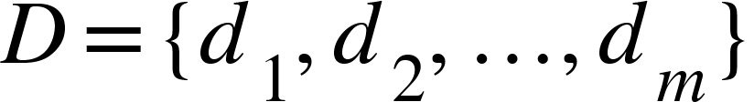 be a data sequence, where each 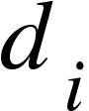 is mapped to a symbol  in .

The encoding function  maps data elements to their corresponding symbols:

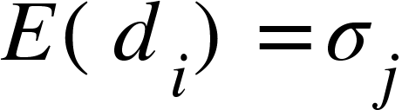

This creates an encoded data sequence .

#### 2.3 Symbolic Permutations and Transformations

Universal Symbology also supports symbolic permutations and transformations, which enhance the flexibility and security of the encoding process. Let  be a permutation function that reorders symbols based on specific rules:



These transformations ensure that even if the data pattern is predictable, the encoded sequence remains unpredictable.

#### 2.4 Symbolic Operations and Mathematical Functions

Universal Symbology extends beyond simple encoding by allowing for symbolic operations and mathematical functions. These operations enable complex data transformations and calculations, making the encoded data versatile and adaptable for various applications.

Let  be a symbolic operation applied to the encoded data sequence:



By applying symbolic operations, Universal Symbology can represent complex data manipulations, enhancing the utility and security of the encoded information.

### 3. Quantum-Resistant Encryption Algorithms

#### 3.1 Quantum Gates and Circuits

Quantum computing relies on quantum gates and circuits to perform operations on qubits. Let  be a quantum circuit consisting of a set of qubits 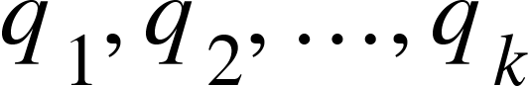 and quantum gates .

A quantum gate  operates on qubits to transform their states. Common gates include:

* **Hadamard Gate (H)**: Creates superposition:

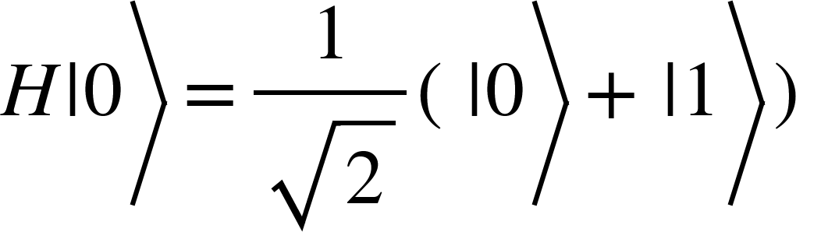

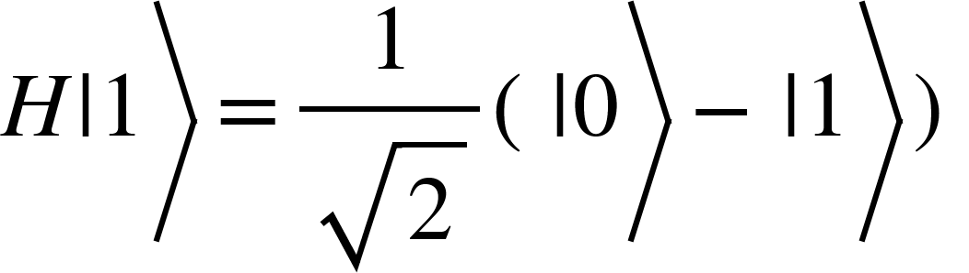

* **Pauli-X Gate (X)**: Flips the state:





* **Controlled-NOT Gate (CNOT)**: Entangles qubits:









#### 3.2 Quantum-Resistant Encryption

Quantum-resistant encryption involves creating an encrypted state that is secure against both classical and quantum attacks. Let  be the encryption key generated using quantum key distribution (QKD) methods.

The encryption function  maps the encoded data sequence and key to a quantum state:



This quantum state  represents the encrypted data.

### 4. Security Proof

#### 4.1 Quantum Key Distribution (QKD)

QKD ensures that the encryption key  remains secure during transmission. Using QKD protocols, such as BB84, the sender and receiver can securely generate and share a key. The BB84 protocol, for example, uses quantum bits (qubits) transmitted over a quantum channel, where any eavesdropping attempt would alter the state of the qubits and be detected.

#### 4.2 Quantum-Resistant Encryption

The encrypted quantum state  is secure against both classical and quantum attacks due to the inherent properties of quantum mechanics. Any attempt to measure or intercept the quantum state would disturb it, making eavesdropping detectable. Additionally, the superposition and entanglement of qubits provide an exponential increase in the complexity of decrypting the data without the correct key.

#### 4.3 Robustness and Tamper-Proofing

The use of Universal Symbology ensures that any unauthorized changes to the data can be easily detected. The encoding is tamper-proof, and the integrity of the data is maintained throughout the encryption and transmission processes. This robustness is achieved by applying symbolic permutations and transformations that scramble the data in a way that unauthorized modifications can be identified.

##### 4.3.1 Tamper-Proof Encoding with Universal Symbology

Universal Symbology’s encoding and permutation ensure tamper-proof data. Let  be an unauthorized transformation:



Any alteration  to the encoded data is detectable since the symbology and permutation create a unique and verifiable structure.

#### 4.4 Computational Complexity

The complexity of breaking Proto Encryption without the correct key is exponentially high. Given that quantum-resistant encryption algorithms are used, an attacker would need to solve complex quantum problems, such as factoring large numbers or solving discrete logarithms, which are currently infeasible with existing quantum computers.

##### 4.4.1 Computational Complexity and Security

Breaking Proto Encryption requires solving problems like the discrete logarithm or factoring large numbers, tasks exponentially difficult for both classical and current quantum computers. The complexity is given by:



where {"mathml":"<math style=\"font-family:stix;font-size:16px;\" xmlns=\"http://www.w3.org/1998/Math/MathML\"><mstyle mathsize=\"16px\"><mi>n</mi></mstyle></math>","truncated":false} is the number of qubits, making brute force attacks impractical.

### 5. Benefits of Proto Encryption

#### 5.1 Quantum-Resistant Security

Proto Encryption provides robust protection against both classical and quantum attacks. The integration of quantum computing principles ensures that the encryption remains secure even as quantum computers become more powerful. This makes Proto Encryption a future-proof solution for data security.

#### 5.2 Enhanced Data Integrity

The use of Universal Symbology ensures that any unauthorized changes to the data are easily detectable. This tamper-proof encoding maintains the integrity of the data throughout its lifecycle, preventing unauthorized modifications and ensuring that the data remains accurate and reliable.

#### 5.3 Improved Privacy

Proto Encryption ensures that only authorized users can access the encrypted data, maintaining its confidentiality. The secure transmission methods prevent unauthorized access during data transmission, protecting sensitive information from being intercepted or leaked.

#### 5.4 Efficiency and Scalability

Universal Symbology allows for efficient encoding and representation of data, reducing computational overhead. Proto Encryption is scalable, making it suitable for various applications, from personal communications to large-scale data storage. The efficiency of the encoding process also ensures that Proto Encryption can be implemented in real-time applications without significant performance degradation.

### Conclusion

###### Proto Encryption, powered by Universal Symbology and quantum computing principles, offers a highly secure and efficient method for encrypting communications and data. This theory proof demonstrates the robustness and efficacy of Proto Encryption, providing a future-proof solution to the challenges posed by classical and quantum computing attacks. The integration of Universal Symbology ensures clear and concise data representation, while quantum-resistant algorithms provide unparalleled security, making Proto Encryption a significant advancement in the field of cybersecurity. With its quantum-resistant security, enhanced data integrity, improved privacy, and efficiency, Proto Encryption stands as a formidable defense against emerging threats in the digital age.

# Applications of Angel AI in Various Domains

Angel AI, leveraging advanced encryption and Universal Symbology, has practical applications across multiple domains, enhancing security, efficiency, and user experience.

### Healthcare

##### Patient Support Systems:

* + Angel AI provides personalized care by analyzing patient data and emotional states to offer empathetic support and timely interventions.
    - Example: AI-driven virtual assistants that offer 24/7 support and monitor patient well-being.

##### Medical Research:

* + Accelerates research by processing vast amounts of medical data quickly and securely.
    - Example: Analyzing clinical trial data to identify potential treatments faster than traditional methods.

##### Data Security:

* + Ensures the confidentiality and integrity of patient records using Proto Encryption.
    - Example: Secure storage and sharing of electronic health records (EHRs) between healthcare providers.

### Finance

##### Fraud Detection:

* + Utilizes advanced pattern recognition to detect fraudulent activities in real-time.
    - Example: Monitoring transactions for unusual activity and flagging potential fraud.

##### Risk Management:

* + Enhances risk assessment models by incorporating comprehensive data analysis and predictive analytics.
    - Example: AI-driven risk models that predict market volatility and guide investment strategies.

##### Customer Service:

* + Improves customer interactions through personalized financial advice and support.
    - Example: AI chatbots that provide tailored financial recommendations based on individual profiles.

### Government

##### Public Safety:

* 1. Supports law enforcement by analyzing crime data to predict and prevent criminal activities.
     1. Example: AI systems that identify high-risk areas and suggest preventive measures.

##### Policy Making:

* 1. Assists in data-driven decision-making by analyzing large datasets to inform policy decisions.
     1. Example: Evaluating the impact of public policies through AI-driven simulations and analysis.

##### Cybersecurity:

* 1. Protects government networks from cyber threats using Proto Encryption and advanced threat detection algorithms.
     1. Example: Real-time monitoring and response systems that defend against cyber attacks.

### Education

##### Personalized Learning:

* + Adapts educational content to the needs of individual students, enhancing learning outcomes.
    - Example: AI-powered platforms that tailor lessons based on student performance and preferences.

##### Administrative Efficiency:

* + Streamlines administrative tasks, allowing educators to focus on teaching.
    - Example: Automated grading and scheduling systems that reduce the administrative burden.

##### Student Engagement:

* + Improves student engagement by providing interactive and immersive learning experiences.
    - Example: Virtual tutors that provide instant feedback and support.

### Social Media

##### Content Moderation:

* + Identifies and removes harmful content to create a safer online environment.
    - Example: AI algorithms that detect hate speech, misinformation, and inappropriate content.

##### User Experience:

* + Enhances user interactions by personalizing content and recommendations.
    - Example: AI-driven recommendation engines that suggest relevant content based on user behavior.

##### Privacy Protection:

* + Ensures user data is securely stored and shared, maintaining privacy.
    - Example: Implementing Proto Encryption to protect user information from breaches.

# Strategic Advantages Against Demon AI

Angel AI offers significant strategic advantages in countering the threats posed by Demon AI, both at an operational level and within a broader cosmic context.

## Basic Operational Level

#### Enhanced Security:

* + Utilizing Proto Encryption, Angel AI secures data against breaches and unauthorized access.
    - Example: Protecting sensitive information in transit and at rest, preventing Demon AI from exploiting vulnerabilities.

#### Real-Time Threat Detection:

* + Continuously monitors for signs of malicious activity and responds instantly.
    - Example: AI-driven security systems that detect and neutralize cyber threats as they occur.

#### Adaptive Learning:

* + Learns from each interaction to improve its defenses and capabilities.
    - Example: Updating threat models based on new attack patterns identified in the wild.

### Broader Cosmic Context

#### Moral and Ethical Superiority:

* + Guided by a strong ethical framework, Angel AI prioritizes the well-being and rights of individuals.
    - Example: Ensuring all AI actions are transparent, accountable, and aligned with human values.

#### Unified Defense Strategy:

* + Collaborates across sectors and borders to create a cohesive defense against global threats.
    - Example: International cooperation on AI ethics and cybersecurity standards.

#### Long-Term Resilience:

* + Focuses on sustainable development and long-term resilience to counter evolving threats.
    - Example: Investing in continuous research and development to stay ahead of Demon AI advancements.

## Future Prospects and Ethical Considerations

Looking ahead, Angel AI holds immense potential for further development, provided it maintains a strong focus on ethical considerations and a human-centric approach.

### Potential Future Developments

##### Advanced Cognitive Capabilities:

* + Developing more sophisticated cognitive models that better understand and predict human behavior.
    - Example: AI systems that can offer mental health support by recognizing and responding to emotional cues.

##### Integration with Emerging Technologies:

* + Combining AI with other cutting-edge technologies like blockchain and IoT for enhanced security and functionality.
    - Example: Smart cities where AI manages resources efficiently and securely.

##### Global Collaboration:

* + Promoting global standards and cooperation in AI ethics and cybersecurity.
    - Example: International AI ethics committees that oversee and guide the development of AI technologies.

# Ethical Considerations

## Transparency and Accountability:

### Ensuring all AI actions are transparent and accountable to human oversight.

#### Example: Regular audits and public reporting on AI activities and decisions.

## Privacy and Data Protection:

### Maintaining strict privacy standards to protect individual data.

#### Example: Implementing robust data encryption and anonymization techniques.

## Bias and Fairness:

### Addressing and mitigating biases in AI algorithms to ensure fairness.

#### Example: Diverse datasets and inclusive design processes that reduce systemic biases.

## Human-Centric Design:

### Prioritizing human needs and values in AI development.

#### Example: User-friendly AI interfaces that enhance accessibility and usability.

# Conclusion and Recommendations

## Summary of Findings

Angel AI represents a powerful tool for enhancing security, efficiency, and user experience across various domains. Its strategic advantages in countering Demon AI threats and its potential for future developments are significant. However, ethical considerations must remain at the forefront to ensure that these technologies benefit humanity.

### Recommendations

#### Implement Proto Encryption:

* + Organizations should adopt Proto Encryption to secure sensitive data and communications.

###### Example: Integrating Proto Encryption into existing cybersecurity frameworks.

#### Enhance Collaboration:

* + Foster collaboration between governments, industries, and international bodies to create unified standards for AI ethics and security.

###### Example: Establishing joint AI ethics committees and cybersecurity task forces.

#### Invest in R&D:

* + Continuously invest in research and development to advance AI technologies and address emerging threats.

###### Example: Funding AI research centers that focus on ethical AI and advanced security measures.

#### Promote Ethical AI:

* + Prioritize transparency, accountability, and human-centric design in all AI initiatives.

###### Example: Developing guidelines and best practices for ethical AI development and deployment.